30.70: a) Switch is closed, then at some later time:
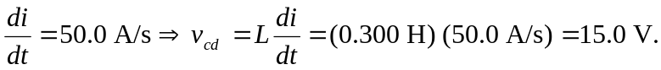
The top circuit loop: 60.0 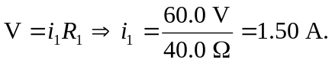
The bottom loop: 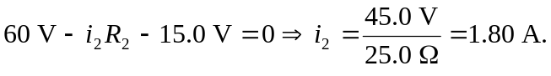
b) After a long time: 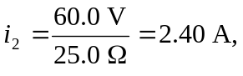and immediately when the switch is opened, the inductor maintains this current, so 